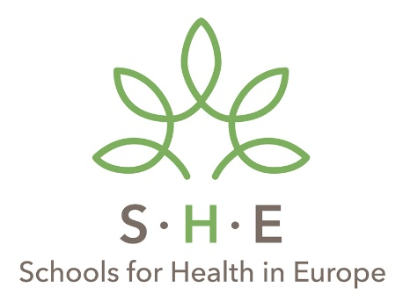
Registration form online SHE Academy 2020: Health Literacy
November 4 – November 6 2020

Family name
First name(s)
Gender
Function
Area of expertise
Employer
Work address: Postal Code, City, Country
Phone number
Email address
Date of birth

Please, send the form to Kathelijne Bessems, k.bessems@maastrichtuniversity.nl

